Telephone etiquette



1. Answering a call

- First Impressions are lasting! The way a company answers the phone tells us a lot about the kind of service we can expect to receive from them. How you answer the call, sets the tone of the entire call.
The basic rules are as follows:

- Pick up the phone within three rings.

- Smile while greeting the caller.

- Give your company / department name and your name.

- Ask the customer if you can help.

- Pick up the phone within 3 rings. This is the general accepted standard. After the third ring, our tolerance as customers starts to waver.

- If you hear a phone ringing in the department in which you are working and no one picks it up, make it your business to do so. Even if you can’t personally help the customer you can at least take a message and further the cause of good customer relations.

A company’s answering standard should include the following:

- Greet the customer – greeting should always be the entry point of a phone conversation because it instantly indicates your friendliness and openness to the other person. It’s a kind of verbal handshake.
When answering the phone say: “Good morning/afternoon” before you identify yourself and the company.

- Identify your company and yourself – this basic courtesy lets the caller know that she has reached the correct person, department or company. Remember the caller can’t see if he is at the right company or department.

- Ask how you can help. Saying this demonstrates that you and your company are ready and available to assist the customer.

- Use the caller’s name frequently during the call. Ask the caller’s name and write it down at the beginning of the conversation. This makes the caller feel that he is not just a “number”.


- Tone of voice. A smiley, lively voice is always far more welcoming than a dull, lifeless voice. Think of how you sound when you are greeting someone you want to see and how you sound when it is someone you don’t like to see.



2. Putting a caller on hold
Activity 3

The following is a good guideline to follow when you need to put a customer on hold:

- Ask the caller if it is OK to put them on hold e.g. “Would you mind if I place you on hold?”

- Offer the customer a choice: being placed on hold, phoning back later or taking a message.

- Don’t keep the caller waiting too long.

- Use hold and transfer features effectively.

- Focus on keeping the customer informed on what you are doing to help them.

1. Greetings

2. Identify yourself, company/department

3. Offer to help

4. Resolve query or

5. Ask to be placed on hold / transfer / take a message

6. Keep your promise
3. How to transfer a call?
Activity 4

When transferring a call:
- Explain to the customer why he is transferred, it gives the customer information and a choice.
- Give the name and number of the person you are transferring the customer to. If the customer is disconnected he can call the person directly.
- Confidential information: make sure that you know what information is confidential in your company. Don’t give any employer’s personal or home telephone number to a customer, unless the person gave you permission to do so.

4. Using empathy on the telephone
- Empathy means understanding your customer’s point of view, regardless of whether or not you agree.
- Empathic phrases to practise, remember and use in a company that will make the customer feel good are:

- “I can see why you feel that way.”
- “I see your point of view.”
- “I hear what you are saying.”
- “I am sorry it happened.”



5. Taking messages
Activity 5

Provide the following when you take down a message:

- Full name and surname of the person the message is FOR.
- Full name and surname of the person the message if FROM.
- Name of the COMPANY the person is calling from.
- 2 TELEPHONE NUMBERS: cell phone and landline.
- DATE – day, month and year.
- TIME person called.
- Short but detailed MESSAGE.
- Your name and surname as the person who took the message.
- IMPORTANT: make sure the person gets the message.

6. Ending a call

- Don’t underestimate the importance of ending the call on a positive note. Particularly, if the caller has been “difficult”.
- Examples of how to end a call positively:
- Both you and the customer must agree on what is going to be done. Therefor repeat the action steps you are going to take.
- Ask the customer if you can do anything else for him.
- Thank the customer for the call.

Activity 6: Skills practice

Activity 7: Key learning

Activity 8: Self-evaluation

Activity 9: Exercises to complete at home

ACTIVITY 1
Testing your telephone etiquette

Before we deal with the do’s and don’t’s of telephone etiquette, let’s test your current knowledge by rating each of the following scenario’s as TRUE or FALSE. Only write T or F on the line.

Scenario one

It’s 11:45 and Sandra is at her desk putting the final touches on her sales report, which is due at noon. She is on the final page when the phone rings. She tries to ignore it for a few moments, but the ringing continues. Eventually she picks up the phone and says with a smile: “This is Sandra, how may I help you?”

Sandra is demonstrating good telephone etiquette: __________

Scenario two

Sipho is a sales assistant at a large hardware store. His supervisor, Debra, is having a meeting with him about some new stock that has just arrived. Sipho’s telephone rings. He immediately pick it up, greets the customer on the other end and politely says: “Let me put you on hold for just a minute.”

Sipho is demonstrating good telephone etiquette: __________

Scenario three

Gerhard is a travel agent. His area of speciality is domestic travel. His phone rings and on the line is a customer who needs help booking an overseas trip. Gerhard explains to the customer that he does not deal with foreign travel by saying: “I am sorry, you’ve reached the domestic travel department, and you need to talk to international. Hold on for a moment, I will transfer you.”

Gerhard is demonstrating good telephone etiquette: __________

How did you do? If you marked any of the scenarios as true, think again! All of the above scenarios are false because they broke some aspect of telephone etiquette. Therefor the customer would get a negative impression of the company.

ACTIVITY 2
Answering a call

1. Based on your experience of when you have phoned different companies, why is it important to have an answering standard when you answer the phone?

_____________________________________________________

_____________________________________________________

_____________________________________________________

2. Set up your own answering standard for your company. What will be included in the standard?
_____________________________________________________

_____________________________________________________

_____________________________________________________

_____________________________________________________

3. Use your own company name and write the direct words that will be used when a telephone is answered in your company.

_____________________________________________________

_____________________________________________________

_____________________________________________________
ACTIVITY 3
Putting a customer on hold

In scenario two, Sipho did not ask the customer if he could put him on hold – he told him. This can be very frustrating for a customer. Furthermore, Sipho did not ask permission to take the call in the first place. The person standing in front of you is as important as the person on the telephone. Acknowledge this with a gesture or “May I answer quickly?” before reaching for the phone.

The etiquette for putting your customers on hold will help you avoid becoming confused and thereby avoid the many negative moments of truth that the customer associates with the telephone.

Think of a particular scenario that you / your parents were involved in and then discuss the following questions:

1. How did you feel when someone put you on hold for a long time?

_____________________________________________________

_____________________________________________________

_____________________________________________________

2. What did the person say before he/she put you on hold?

_____________________________________________________

_____________________________________________________

_____________________________________________________


3. What was your impression of the customer service?

_____________________________________________________

_____________________________________________________

4. Did the person say anything that made you as a customer, feel special?
What did he say?

_____________________________________________________

_____________________________________________________

5. Why do people dislike being put on hold?

_____________________________________________________

_____________________________________________________

6. How should you approach the caller before putting him on hold?

_____________________________________________________

_____________________________________________________

7. What is wrong with putting your hand over the receiver?

_____________________________________________________

_____________________________________________________

8. Why should you explain to a customer why he is being transferred?

_____________________________________________________

_____________________________________________________

ACTIVITY 4
How to transfer a call

In your groups, discuss the following:

1. Why should you explain to the customer why he is being transferred?

_____________________________________________________

_____________________________________________________

_____________________________________________________

2. Why should you give the customer the person’s name and telephone number before you transfer his call?

_____________________________________________________

_____________________________________________________

_____________________________________________________

3. Are you allowed to give employers’ personal information to customers?

_____________________________________________________

_____________________________________________________

_____________________________________________________

ACTIVITY 5
Taking a message

Study the following two messages and then answer the question.

 | MESSAGE 1 |  |  | MESSAGE 2
To | Khumalo |  | To | Khosi Matshitse
Date | 18th |  | Date | 15 March 2004
From | Sarel |  | From | Ronel Jacobs
Company |  |  | Company | BP Personnel
Tel no | You have it |  | Tel no | 011 555 4512
Message |  |  | Message | Ronel needs the detail on case 26 urgently.
Taken by | Maria |  | Taken by | Maria Matsana

1. Which message is the better one? ____________________ (1)

2. Motivate your answer. (7)

- __________________________________________________

- __________________________________________________

- __________________________________________________

- __________________________________________________

- __________________________________________________

- __________________________________________________

- __________________________________________________

3. Use the scenario that follows to complete the message slip.

Mr. Combe, the principal of Kings High, phoned at 11:25 to talk to the principal of Queens High, Mrs Kastanos. He wants to discuss the program for the athletic meeting taking place during the weekend. Mrs. Kastanos is busy with a meeting and can’t take the phone call. Mr. Combe asked to be phoned back after the meeting on his cell phone – 084 6622 315

MESSAGE
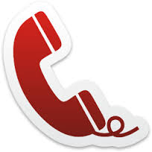

To: ____________________ Date: _________ Time: ____

From: __________________ Company: _______________

Tel. no. _________________

Message: _______________________________________________

_______________________________________________________

Taken by: _______________

TOTAL 20

ACTIVITY 6
Skills practice

Practice the following three skills with a friend. Give informative feedback to the person practising the skill so that he can better himself.

Quality check according to: | FEEDBACK
Answering a telephone.
Ensure they used the agreed procedure
- Pick up the phone within 3 rings
- Greet the caller
- Give your company / department name as well as your own
- Ask the customer how you can help.
Putting a caller on hold.
Ensure they used the agreed procedure
- Did he ask the caller permission to be put on hold and to be transferred?
- Did he give the caller the name and number of the person to whom they are being transferred?
- Did he tell the person being called who was on the line and why?
Taking a message for another person.
Ensure they used the agreed procedure
- Did he take all the caller’s relevant details?
- Did he summarise the message correctly?
- Did he check for accuracy e.g. repeating the telephone number?

ANNEXURE 5: Year 3 Term 4
READING
- What is reading but silent conversation? (Walter Savage Landor)
Reading applies to written text (paper) and visual media. In the workplace, most people would be surprised if they ever physically timed themselves, to discover that they spend a lot of time reading: memos, e-mail, internet research, letters, reports, advertising, articles, textbooks, computers and cell phones.

- Why is reading so important?
With the huge amount of written material (in books, magazines, internet, emails, reports etc.) the old saying, “Don’t believe everything you read”, has never been truer!
The world of work is an ever-changing, increasingly demanding environment. What was the ‘latest and greatest’ last year is now old news. While this is exciting, it is also very pressurising.
We have to stay abreast of changes and we have to constantly improve our knowledge and skills to remain employable. Reading is inseparable from lifelong learning.
The usual complaint about time is that there just aren’t enough hours in the day. There are, however, two possible solutions to this problem: we can learn to read faster and/or become a more selective reader

- The 3 circles are a useful tool for selective reading:

The circle represents the sum total of all the knowledge in the world.

I know this

I will never know this

I must learn this

You can make the outer circle a lot bigger by reading newspapers, searching the Internet, reading on new topics and watching television.

4. Motivational phrases to read every day?
Write it on colourful paper and put it up all over your room:
- Knowledge belongs to everyone.
- It is completely within my power to increase my knowledge.
- Knowledge is not static – it is always increasing.
- Knowledge is truly power.
- Reading is one of the main routes to better knowledge.
- Self-improvement depends on increasing our knowledge.

Do activity 1: Reading

5. Reading methods

5.1 Speed reading
Remember when you first learned how to read as a child? It was a painfully slow process: The – cat – sat – on – the – mat… That was because your brain had to process each word individually. As you recognised words, you speeded up.

Just see how amazing your brain works! Read this:

I cdnuolt blveiee taht I cluod aulaclty uesdnatnrd waht I was rdanieg The phaonmneal pweor of the hmuan mnid Aoccdrnig to a rscheearch at Cmabrigde Uinervtisy, it deosn't mttaer inwaht oredr the ltteers in a wrod are, the olny iprmoatnt tihng is taht the frist and lsat ltteer be in the rghit pclae. The rset can be a taotl mses and you can sitll raed it wouthit a porbelm. Tihs is bcuseae the huamn mnid deos not raed ervey lteter by istlef, but the wrod as a wlohe. Amzanig huh? yaeh and I awlyas thought slpeling was ipmorantt!
Test yourself by timing how long you take to read the following passage of just
over two hundred words. Read silently, to yourself. You must read to comprehend.

Do activity 2: Speed Reading.

5.2 Skimming and Scanning

  - Quickly read through text to safe time when you search for information.
  - Intentionally skip parts of the text.
  - Only pay attention to specific information.
  - Focus on headings, sub headings, italic or bold words, words and pictures standing out.
  - Use it to find specific information like numbers, amounts, dates, names etc.
  - Where do you use it? Look up telephone numbers in a telephone directory, words in a dictionary, studying a weather chart or a bus schedule, searching websites etc.

Do activity 3 on Skimming and Scanning

5.3 Study reading

  - Slowest kind of reading.
  - Read carefully leaving nothing out.
  - Read with attention.
  - Think about what you read.
  - Stop frequently to check if you remember and understand.
  - Try to memorise what you have read.
  - KEYWORDS: the most important words in a sentence or paragraph are highlighted. It enables you to understand a sentence and focus on the essence of the sentence.

Do activity 4 on Study Reading

Information
Literacy

You will need information literacy skills throughout your life. We are always seeking information. What is the best car to buy? Which courses should I study? Which is the best book to read on a particular subject? How will I convince my boss that this is a good idea? How to learn to do something new?

Information helps us to make the best decisions! It also helps us to communicate more effectively, because we are speaking with confidence, based on facts. However, the good stuff is often buried beneath heaps of rubbish.
The skill of searching, sifting, evaluating and comprehending written and visual literacy, is therefore vital to our effectiveness in the world of work.

1. How do I choose the correct media to search for information?

I must know what kind of information I want to know where to start searching for it. Some examples:

What information do I need? o | Media that is used
To sell a product
To give information
To persuade
To manipulate
To entertain
To scare
To educate

Do activity 5: Information Literacy

2. Posters

Posters can be a very effective form of communication. You may have learnt in History about or seen in movies the posters used by different nations during war or times of political change. They all had read: “Your country needs you”. It was very persuasive because it addressed the emotions and patriotism of the men.
Posters are seen on lamp posts, on information boards inside/outside shops, at schools, concerts etc. Posters are usually big enough so that a driver can read it when driving past it. Some posters have photos to draw the attention of the reader.

What are the characteristics that make a poster an effective tool of communication?

  - A poster should be eye-catching.
  - Give the minimum, but vital information in as few words as possible.
  - The information must stand out. Use letter types that are big and clear and that can be read at a glance from a distance.
  - Use bright colours to attract attention.
  - The poster must be uncluttered.

Do activity 6: Design a poster

3. Critical eye

A critical eye, or the ability to evaluate what you are reading for bias, authenticity and reliability, is an important skill when reading – especially if you are doing research. Writers have many purposes in mind when they write – to sell, to persuade, to inform etc.

In evaluating a persuasive text (selling and idea or concept) the critical reader should be able to classify the information given according to the following hierarchy of reliability:

- Facts – verified either by experience or reference to authoritative records
- Conclusions – derived from facts by reasoning about it
- Judgements – derived by reflection on the material given (the professional competence of the person judging weighs heavily here)
- Opinions – need careful evaluation, even if they ring true
- Beliefs – views that have no factual backing. Often underpin our thoughts and are ‘unstated’, but evident if you are on the look out for bias

Do activity 7: Critical Eye

Activity 1: Reading

1. Why is reading so important? (5)

_____________________________________________________

_____________________________________________________

_____________________________________________________

_____________________________________________________

_____________________________________________________

2. Explain the 3 circles of reading priorities? (3)

_____________________________________________________

_____________________________________________________

_____________________________________________________

3. Explain how you can make the outer circle bigger? (3)

_____________________________________________________

_____________________________________________________

_____________________________________________________

4. What will you do to motivate yourself to expand your reading? (4)

_____________________________________________________

_____________________________________________________

_____________________________________________________

_____________________________________________________

5. What would you like to learn more of? (5)

_____________________________________________________

_____________________________________________________

_____________________________________________________

______________________________________________

TOTAL 20

Activity 2 Speed Reading

The teacher is going to be the timekeeper. The teacher will tell you when to start reading and when to stop. It is going to be exactly 60 seconds. Read the passage in the notes silently to yourself.
Make a mark on the text where you stopped reading. Count the words.

Repeat above steps 3 times.

1st ___________ words per minute

2nd ___________ words per minute

3rd ___________ words per minute

1. What conclusion do you come to after you did the exercise three times?

_________________________________________________________

2. By doing this exercise twice a day at home, what could you expect after a week?

_________________________________________________________

3. What can you do to motivate yourself to read more?

_________________________________________________________

_________________________________________________________

Activity 3 Skimming and Scanning

Skim the article: “Snapshot of SA Cyberspace” and answer the questions.

1. What is the title of the article? __________________________

2. Who is the author? ___________________________2

3. In which magazine did the article appear? ________________

4. On what date did it appear? __________________________3

5. What city has the biggest Facebook population in S.A. ?

________________________

6. Which city has 840 000 Facebook users? ________________

7. What is the average number of photos uploaded everyday
worldwide? ________________

8. How old is the biggest percentage of users? _____________2

9. Are the most Facebook users male or female? ____________

10. How many Facebook users are there in S.A.? ____________2

TOTAL 15

Activity 4
Study Reading

Apply Study Reading on the article: “Balls, glorious balls” and answer the questions.

1. What is the heading? _____________________________

2. What is the sub heading? __________________________

______________________________________________4

3. Who made the first rugby ball? _______________________

_______________________________ 2

4. What was the ball made of? _________________________2

5. How did they inflate the balls? ________________________2

6. What are rugby balls made of today? ___________________

_________________________________________________5

7. How many stitches are there on a cricket ball? ____________2

8. What is used to stuff cricket balls and what do they weigh?

_________________________________________________2

9. Where and when was the most expensive cricket ball ever
made? ___________________________________________2

10. Give three reasons why it is the most expensive cricket ball.

__________________________________________________

_________________________________________________3

Total 25
ACTIVITY 6
Poster

Choose one of the following:

1. Design a poster that demonstrates the dangers of pollution.
2. Design a poster that illustrates your culture.
3. Design a poster to advertise your own business.

Marks will be given for:

- Catch the eye (10)
- Minimum information (10)
- Words standing out (10)
- Letters bright and clear (10)
- Pictures and colours (10)

TOTAL 50

ACTIVITY 7
Critical eye

Give an example at each of the following:

- Fact

_____________________________________________________

- Inferences

_____________________________________________________

- Judgements

_____________________________________________________

- Opinions

_____________________________________________________

- Believes

_____________________________________________________

Study the following examples and only write down the correct number at each example.

Word | Number | Example
Fact |  | 1. Mr Lombard is absent today because he is ill.
Inferences |  | 2. I think you are a nice guy.
Judgements |  | 3. There are seven days in a week.
Opinion |  | 4. You are guilty because you were in Game when the  iPad was stolen.
Believes |  | 5. You are a thief.

TOTAL 10

SUMMARY
12 Ways Your Phone Is Changing You by Tony Reinke is a thoughtful exploration into how our smartphone technology can—and most likely already has—influenced how we live our lives. Beyond the obvious convenience smartphones bring into our lives, these portals to social media platforms, virtual communities, near-instant service, and continuous streams of information produce non-obvious changes that alter the ways we interact with each other and with God.

Do You Control Your Phone — Or Does Your Phone Control You?
Within a few years of its unveiling, the smartphone had become part of us, fully integrated into the daily patterns of our lives. Never offline, always within reach, we now wield in our hands a magic wand of technological power we have only begun to grasp. But it raises new enigmas, too. Never more connected, we seem to be growing more distant. Never more efficient, we have never been more distracted.

- Fear of Missing Out
Do you know what nomophobia is? No-mobile-phone phobia. FOMO (fear of missing out) hits us on two sides: anxiety that we’re not staying updated on information if we’re not checking our phone, and insecurity of not getting the affirmation we want if we’re offline.

A need to use the cell phone more and more often.
- Preoccupation with smart phone use.
- Turns to cell phone when experiencing unwanted feelings such as anxiety or depression.
- Excessive use characterized by loss of sense of time.
- Has put a relationship or job at risk due to excessive cell phone use.

ToleranceNeed for newest cell phone, more applications, or increased use.
- Withdrawal, when cell phone or network is unreachable.
  - Anger.
  - Tension.
  - Depression.
  - Irritability.
  - Restlessness.
If you or a loved one displays these signs and symptoms of cell phone addiction, help is readily available. Call the phone number above to speak with a treatment specialist about various recovery options.
- Car accidents.
  - Many people believe that they can multitask and use their phones while driving, but this causes significant impairment and puts the driver and others on the road in danger.
  - Research has revealed that texting and driving can be just as dangerous as drinking and driving.⁷
- Seeing teens standing together, but totally ignoring each other is a common sight these days. According to a survey conducted by the Pew Research Center, 78% teens aged between 12 and 17 have mobile phones. And they are not just using it to call their parents. One in four teens have access to the internet, far more than adults. So is cell phone really a good thing for teens? What are the negative effects of cell phones on teenagers? Read on to find the answer.

Effects Of Mobile Phones On Teenagers:
- There is no doubt that the mobile phone is a very useful tool and today, mobile phones are a major part of society. . It eases communication with colleagues, friends and relatives. But every technology that provides such benefits comes with a consequent price. The impact of mobile phones on youth and society is astronomical. It is this area that requires attention, when you are giving your teen a cell phone. Here’s how cell phones affect teenagers.

1.Teen Tendonitis (TTT):
- What is the impact of mobile phones on young people’s social life? Teenagers are totally addicted to texting. Excess messaging can lead to Teen Tendonitis (TTT). It can cause pain in the hands, back and neck due to poor posture. It can also lead to impaired vision and even arthritis down the line.

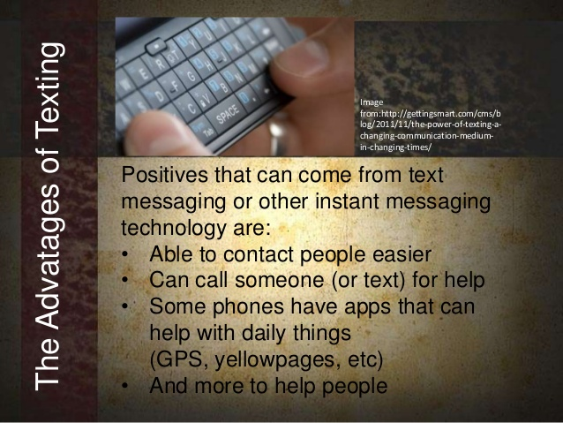

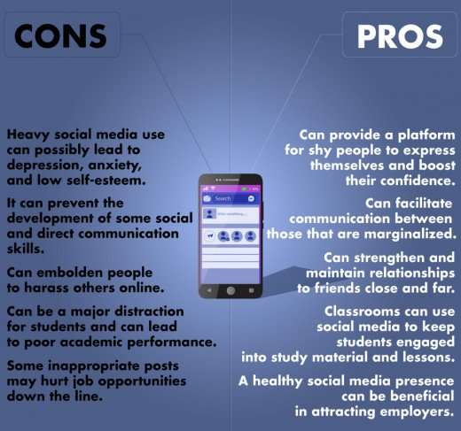

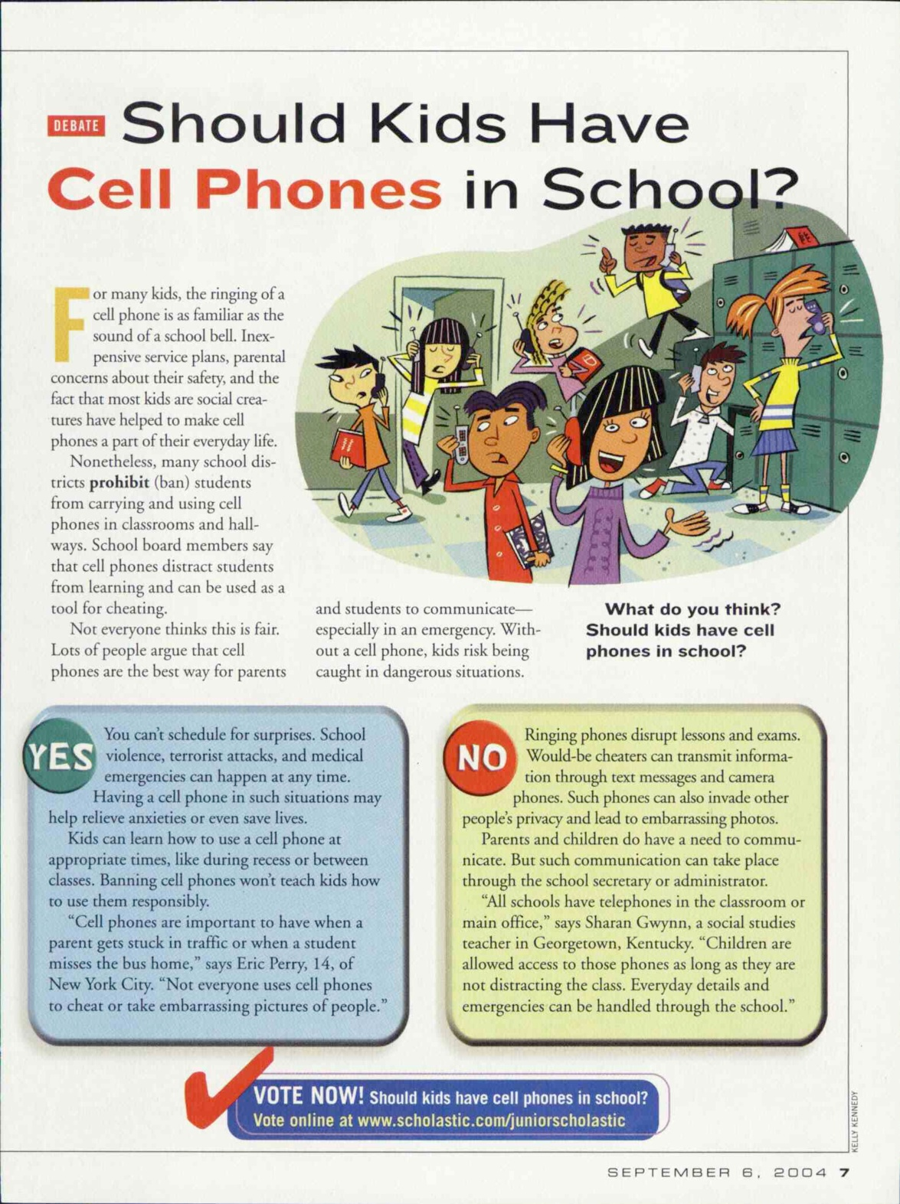

Rubric to assess a discussion
Listening and speaking  30 marks | Level 4 | Level 3 | Level 2 | Level 1
 | 8-10 | 6-7 | 4-5 | 1-3
Participation in debate | Skilfully sustains a conversation; listens to others with respect; takes turns; justifies own point of view; shows excellent understanding of the topic | Takes part in the discussion; listens to others with respect; takes a point of view and sometimes justifies it; takes turns; shows understanding of the topic | Takes part in the discussion adequately; able to listen and follow; few interruptions of others; defends viewpoint adequately; shows some understanding of the topic | Takes little or no part in the discussion; does not listen to others; or frequently interrupts; does not follow the thread of the debat; does not take a viewpoint
Ability to express self orally | Expresses her/himself very well. Able to say what he/she wants to say clearly and easily with few or no mistakes. | Expresses him/herself well. Able to say what he/she wants to say clearly and fairly easily, but with some mistakes. | Expresses him/herself with some difficulty. Struggles to say what he/she wants to say and makes many mistakes. | Struggles to express him/herself orally. Makes many mistakes. Difficult to understand. Says only one or two words.
Voice projection and modulation | Excellent | Very good | Poor | Hampers communication
TOTAL | 30

___________________________________________________________________
Activity 3: READING & VIEWING
Participate in shared / paired / individual reading.
CONTENT
- Pronounce words correctly.
- Recognise new vocabulary.
- Take part in shared reading.
- Read in pairs.
- Read out loud for marks.

Read the following extract out loud.

He ran downstairs to warn our first-floor neighbours, leaving our front door open. I could smell smoke. The sirens had multiplied — three fire trucks outside, maybe four. I turned to the back, where my now 6-year-old son was fast asleep in his bedroom off the kitchen. There were 20 steps between him and me.
“I’ll get him!” I shouted to my husband.
“Great,” he said, already moving. “I’ll grab some stuff and meet you in the car.”

Rating scale: Reading aloud (unprepared) – 25 marks
Description | Marks | Learner’s Marks
Reads a suitable text aloud with good expression, tone, volume and pace; projects voice; reads fluently and pronounces words correctly; answers questions about what is read correctly | 8-10
Reads a suitable text aloud, with some mistakes in pronunciation; makes use of tone, volume and pace; lots of pauses and tends to stop before every word (not fluent); answers some questions about what is read correctly | 4-7
Many mistakes in pronunciation; makes little or no use of tone, volume and pace; learner is almost unable to decode (sound out) words correctly; very little or no understanding of what is read | 0-3
TOTAL | 10÷10x25

DATE: ________________________________ TOPIC: ON FIRE!
___________________________________________________________________
Activity 4: WRITING AND PRESENTING

CONTENT
- Build vocabulary
- Copy the format of a friendly letter.
- Write a letter to your friend.

4.1 Let’s look at a friendly letter

1. HEADING | Your personal address | 12 Ruby Street
1. HEADING | Your personal address | Geduld
1. HEADING | Your personal address | Springs
1. HEADING | Your personal address | 1506
1. HEADING | The date | 17 July 2018
 | SKIP A LINE
2. GREETING | Dear Lerato
 | SKIP A LINE
3.1 INTRODUCTION  3.2 BODY  3. CONTENT  3.3 CONCLUSION | Have you ever thought about what would happen if your house caught fire? What would you save first?
3.1 INTRODUCTION  3.2 BODY  3. CONTENT  3.3 CONCLUSION | SKIP A LINE
3.1 INTRODUCTION  3.2 BODY  3. CONTENT  3.3 CONCLUSION | Last night my brother played with the paraffin stove and accidently set our house on fire. I was terrified.
3.1 INTRODUCTION  3.2 BODY  3. CONTENT  3.3 CONCLUSION | SKIP A LINE
3.1 INTRODUCTION  3.2 BODY  3. CONTENT  3.3 CONCLUSION | First I grabbed my little brother and carried him outside. Next I asked the neighbours to phone the fire brigade. After that we waited for my parents to come home.
3.1 INTRODUCTION  3.2 BODY  3. CONTENT  3.3 CONCLUSION | SKIP A LINE
3.1 INTRODUCTION  3.2 BODY  3. CONTENT  3.3 CONCLUSION | Most of our possessions were lost in the fire. I saved my brother first because he meant more to me than objects. This experience taught me that quick thinking can save lives.
3.1 INTRODUCTION  3.2 BODY  3. CONTENT  3.3 CONCLUSION | SKIP A LINE
3.1 INTRODUCTION  3.2 BODY  3. CONTENT  3.3 CONCLUSION | Hope to see you soon.
4. FINAL GREETING | SKIP A LINE
4. FINAL GREETING | Your friend
 | SKIP A LINE
5. YOUR NAME  5. YOUR NAME | Nomsa

4.2 Copy the format of an informal letter

Your personal ……………….

The …………………………
SKIP A LINE
Dear …
SKIP A LINE
SKIP A LINE
.

SKIP A LINE
SKIP A LINE
SKIP A LINE
SKIP A LINE
Your friend
SKIP A LINE
5) Y…………………………………..
4) F…………………………………..
2) G……………………………..
3.3) C…………………………...
3.2) B……………………………
1) H……………………………
3.1) I…………………………….
3) C………………………………

4.3 Write a letter to your friend. Tell your friend what happened the day your house caught fire. Use the correct format (informal letter).

Rating scale to assess a letter: Self and peer assessment
 | Very good | Good | Needs work
The letter has an introduction, a body and a conclusion
The letter has the address and date in the correct places
Letter has a suitable greeting and final greeting
Letter uses suitable language (informal)

_____________________________________________________________________________________________________________________________________________________________________________________________________________________________________________________________________________________________________________________________________________________________________________________________________________________________________________________________________________________________________________________________________________________________________________________________________________________________________________________________________________________________________________________________________________________________________________________________________________________________________________________________________________________________________________________________________________________________________________________________________________________________________________________________________________________________________________________________________________________________________________________________________________________________________________________________________________________________________________________________________________________________________________________________________________________________________________________________________________________________________________________________________________________________________________________________________________________________________________________________________________________________________________________________________________________________________________________________________________________________________________________________________________________________________________________________________________________________________________________________________________________________________________________________________________________________________________________________________________________________

DATE: ________________________________ TOPIC: ON FIRE!
___________________________________________________________________
Activity 5: PREPARED READING

CONTENT
- Read out loud.

Dear Lerato
Have you ever thought about what would happen if your house caught fire? What would you save first?
Last night my brother played with the paraffin stove and accidently set our house on fire. I was terrified.
First I grabbed my little brother and carried him outside. Next I asked the neighbours to phone the fire brigade. After that we waited for my parents to come home.

Most of our possessions were lost in the fire. I saved my brother first because he meant more to me than objects. This experience taught me that quick thinking can save lives.
Hope to see you soon.
Best wishes
Nomsa

Rubric to assess prepared reading
Criteria | LEVEL 7 | LEVEL 6 | LEVEL 5 | LEVEL 4 | LEVEL 3 | LEVEL 2 | LEVEL 1
MARKS  25 | 10 – 8 | 7 | 6 | 5 | 4 | 3 | 2 – 0
Demonstrates use of tone and inflection | Reads expressively and creates atmosphere. Conveys feelings exceptionally well | Reads with very good expression and attempts made to convey feelings or atmosphere | Reads with good expression and attempts made to convey feelings or atmosphere | Makes an attempt to read with expression | Reads, but with limited expression | Meaning can be followed but not expression | Too poor to be expressive. Meaning lost
Use of voice and mastery of reading skills | Fluent, very entertaining reading  Excellent voice projection and diction which enhances meaning | Fluent reading  Very good voice projection and diction which enhances meaning | Reading fluency in a monotone  Good voice projection and diction which enhances meaning | Reads reasonably fluently  Reading is clear and audible and diction enhances meaning | Reads with limited fluency  Reading is audible and pronunciation does not affect meaning | Reading not fluent  Reading not always audible and many words are mispronounced | Halted reading  Poor pronunciation and poor delivery make the delivery almost incomprehensible
Use of eye / audience contact | Altogether appropriate eye-contact | Very good eye-contact | Good eye-contact | Successful efforts to make eye-contact | Eye-contact adequate | Unsuccessful attempts at making eye-contact | Almost no eye-contact
Responses to questions shows critical interpretation of the text | Handles questions with total confidence, ease and sensitivity to the text | Handles questions with confidence, ease and sensitivity to the text | Handles questions and responds sensibly with minor lapses | Handles questions and responds sensibly with lapses | Understand questions and can answer some of the questions | Understands questions and provides flawed answers | Is mostly unable to understand or respond to questions
Prepared and confident | Reading is exceptionally well prepared and confident | Reader well prepared and reads with confidence | Reader prepared and reads with confidence | Reader is adequately familiar with the text – has made an effort to prepare | Limited amount of preparation. Reads with moderate confidence | Reader has not prepared the text. Obviously nervous | No evidence of preparation. Very nervous and demonstrates a lack of commitment
TOTALS | 50÷2=25
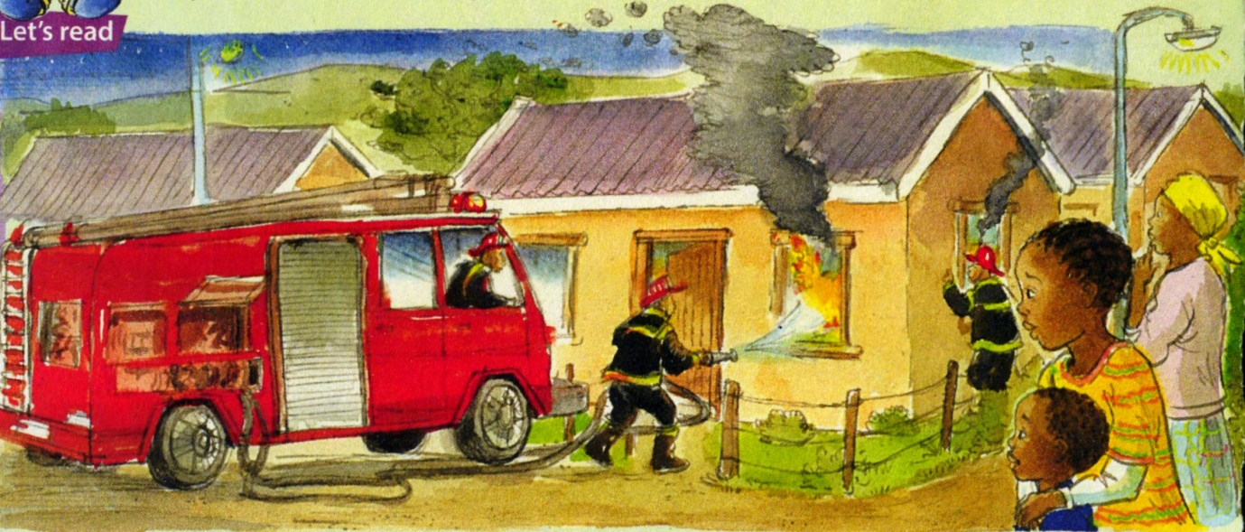

DATE: ________________________________ TOPIC: ON FIRE!
___________________________________________________________________
Activity 6: LANGUAGE STRUCTURES & CONVENTIONS

CONTENT
- Introduce common nouns.
- Underline common nouns in a text.
- Use common nouns in a sentence

Refresher!
Nouns are words that name people, places, things or ideas.

Proper nouns name specific people, places, things or ideas
Lerato, Springs, Woolworths
Since these nouns are naming specific things, they always begin with a capital letter.

Let’s look at common nouns.

Common nouns name people, places, things or ideas that are not specific like woman, city, dog, shoe.
Since these nouns aren’t naming anything specific, they don’t need to start with a capital letter unless they begin a sentence.





6.1 Circle the common nouns that you find in the word search.
Read the following sentences to determine if the words are common nouns.
- The smoke DETECTOR set off the ALARM .
- I ESCAPE through the window.
- My brother found a MATCH lying around.
- We had a PLAN.
- The LOG caught fire.
- When you are caught in a FIRE: STOP, DROP and ROLL.
- Use a MAP to find your way and crawl to SAFETY.
- First TEST if the door is too hot to handle by holding your hand near it.
- The FIRETRUCK stopped in front and a FIREFIGHTER ran through the SMOKE.
- Cross out the words in the list that are not common nouns before you start.
- Cross out the list words as you find them.
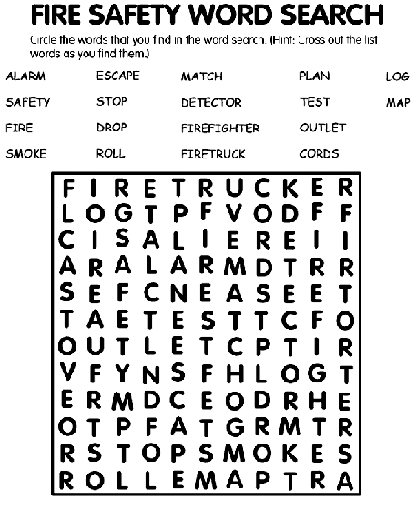
ALARM ESCAPE MATCH PLAN LOG STOP
SAFETY DETECTOR TEST MAP ROLL FIRE
DROP FIREFIGHTER SMOKE FIRETRUCK

6.2 Underline the common nouns in the following text.
On the way to my son’s room, I stopped to put on pants; I put a toothbrush in one pocket and moisturizer in the other. Then I ran into the bedroom and grabbed the hunting knife from my bedside table.

6.3 Fill in a common noun for every proper noun.
Choose the correct words from the box.
dog girl boy truck store river restaurant town

PROPER NOUN  Name specific people, places, things, ideas | COMMON NOUN  Name people, places, things, ideas that are NOT specific
Example: Capitec | bank
Ben
Checkers
Susan
Springs
Ford
Nile
Pit-bull
Spur

6.4 Use common nouns in proper structured sentences.
Complete the sentence by filling in a common noun.

determiner | common noun | verb | adverb
The |  | spread | quickly.

pronoun | verb | preposition | determiner | common noun | adverb
She | ran | to | the |  | immediately.

proper noun | verb | determiner | common noun
Nomsa | called | the

pronoun | verb | conjunction | verb | determiner | common noun
They | arrived | and | saved | the

pronoun | verb | preposition | determiner | common noun
He | crawls | through | the

DATE: ________________________________ TOPIC (2): OUT OF THIS WORLD

___________________________________________________________________
Activity 7: LISTENING & SPEAKING

Let’s look at a poem
CONTENT
- Follow pointer during shared reading
- Take part in short discussion on a poem
- Rap a poem in groups and act it out

7.1 Colour the picture.



Alien
a hypothetical or fictional being from another world.



7.2 Listen to a poem and do shared reading.


THERE’S AN ALIEN IN MY BEDROOM

There’s an alien in my bedroom
He says he comes from outer space.
He’s got three wobbly eyes
and a big round greenish face.


With big green ears and little hands
and tiny feet that smell.
He walked around my bedroom
and very nearly fell.

He came here in a spaceship
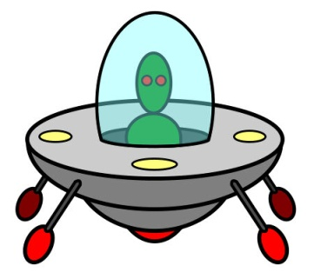
and parked in my back yard.
He says he’s got no petrol
so going home is hard.

He asked me if I could help him
to get his ship to fly.
I filled it up with helium
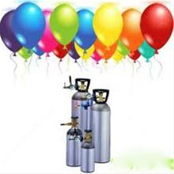
and watched it leave the sky.

Louise Nilon (adapted)

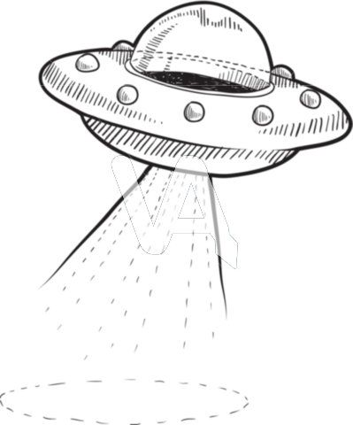
7.3 Discuss the poem.
7.4 Divide into groups and rap the poem.

DATE: ________________________________ TOPIC: OUT OF THIS WORLD
___________________________________________________________________
Activity 8: READING AND VIEWING

CONTENT
- Group read the poem and sing it to a rap sound while acting it out.

8.1 Divide into groups.
8.2 Read the poem “There’s an alien in my bedroom” on page 23.
8.3 Plan how to rap and act it out.

Rubric for dramatic reading

Description |  | Mark
Reads poem aloud with good volume and pace; projects voice; reads fluently and pronounces words correctly. Excellent rap and acting skills. |  | 8-10
Reads poem aloud, with some mistakes in pronunciation; makes use of volume and pace; lots of pauses and tends to stop before every word (not fluent). Rap and acting skills not too bad. |  | 4-7
Many mistakes in pronunciation; makes little or no use of volume and pace; learner is almost unable to decode (sound out) words correctly; very little or no rap and acting skills. |  | 0-3
PROCESSED MARK | 10÷10X25



DATE: ________________________________ TOPIC: OUT OF THIS WORLD
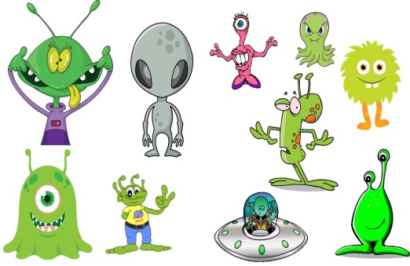
___________________________________________________________________
Activity 9: WRITING AND PRESENTING

CONTENT
- Complete a poem.
- Write own poem.

9.1 Use the correct line in the box to complete a poem.
No one has discovered them yet.
Some might even know how to ride a bike.
Most aliens act really bad.
Some might even know the queen.
Most of them are really sly.

Aliens are strange; you will never know what they are like,
_________________________________________________________
Some are blue some are green.
_________________________________________________________
Aliens often go very mad,
_________________________________________________________
I think that Aliens could maybe fly,
_________________________________________________________
Some are dry some are wet,
_________________________________________________________
9.2 Write your own poem about aliens.
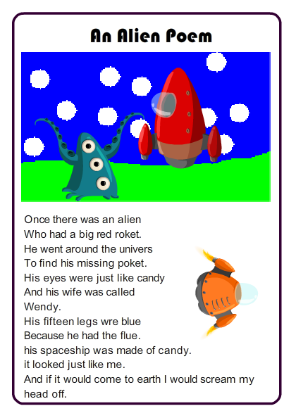
_____________________________________________________________________________________________________________________________________________________________________________________________________________________________________________________________________________________________________________________________________________________________________________________________________________________________________________________________________________________________________________________________________________________________________________________________________________________________________________________________________________________________________________________________________________________________________________________________________________________________________________________________________________________________________________________________________________________________________________________________________________________________________________________________________________________________________________________________________________________________________________________________________________________________________________________________________________________________________________________________________________________________________________________________________________________________________________________________________________________________________________________________________________________________________________________________________

DATE: ________________________________ TOPIC: OUT OF THIS WORLD
___________________________________________________________________
Activity 10: LANGUAGE STRUCTURES & CONVENTIONS

CONTENT
- Introduce proper nouns.
- Underline proper nouns in a text.
- Use proper nouns in a sentence

Refresher!
Nouns are words that name people, places, things or ideas.
Common nouns name people, places, things or ideas that are not specific like
woman, city, dog, shoe.
Since these nouns aren’t naming anything specific, they don’t need to
start with a capital letter unless they begin a sentence.

Let’s look at proper nouns
Proper nouns name specific people, places, things or ideas
Lerato, Durban, Woolworths
Since these nouns are naming specific things, they always begin with a capital letter.

10.1 Specific names for people, places or things
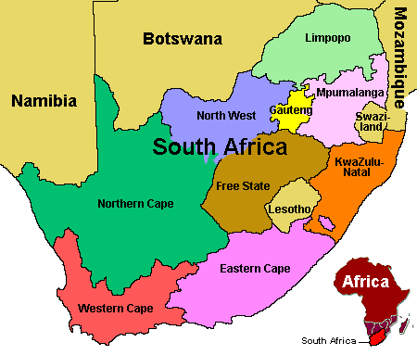
The name of our country.
South Africa


The name of a car.
Ford


The name of a store.
Checkers


The name of a restaurant.
Nando’s




The name of a bank.
Capitec
The name of a woman.
Nomsa


The name of a dog.
Pit-bull


The name of a city.
Johannesburg
Joburg

10.2 Choose five proper nouns on page 28 and write sentences.
_______________________________________________________________________________________________________________________________________________________________________________________________________________________________________________________________________________________________________________________________________________________________________________________________________________

DATE: ________________________________ TOPIC (3): TELLING TALES
___________________________________________________________________
Activity 11: LISTENING AND SPEAKING

CONTENT
- Take part in discussion.
- Draw a picture.
- Participate in shared reading.

11.1 Have a discussion on what aliens look like, what they eat, wear, and their entertainment. Give reasons.










11.2 Picture dictation:
Listen carefully and draw what you hear your teacher describes.

DATE: ________________________________ TOPIC: TELLING TALES
___________________________________________________________________
Activity 12: READING AND VIEWING

CONTENT
- Do shared reading on a poem and prepare for a formal assessment task.



Alien
a hypothetical or fictional being from another world.

Neon
a colourless gas, one of the chemical elements, that is often used in signs because it produces a bright light when an electric current goes through it: a neon sign.

12.1 Listen to the poem.
NEON ALIENS ATE MY HOMEWORK
Okay, I know this sounds totally berserk,
But last night neon aliens ate my homework!
They zoomed down right above my home
And zapped me up inside their dome.
These little green guys glowed brightly in the dark,
Their dripping fangs snapped with the force of a shark.
I was scared out of my wits not knowing my fate.
Thinking to myself, I’m gonna be next on their plate!
What would satisfy the hunger of these guys?
Would they leave me alone if they heard my cries?
I offered them my notebook and even my backpack.
I feared they could make me disappear with a ZIP ZAP!

The aliens weren’t done; they still wanted something to eat.
So I took out my totally finished language worksheet.
That did the trick, and they sent me home without warning.
When I got back, it was eight o’clock the next morning.
I ran in the house and cried for my mom.
She hugged me tight and told me to keep calm.
Mom said, “Just tell your teacher the whole story.
She’ll understand what happened – don’t you worry.
Alien invasions are common in this nation,
And so are kids with fantastic imaginations.”



12.2 Practise pronouncing the rhyme words correctly.
dome
home
berserk
homework

plate
fate
shark
dark

worksheet
eat
cries
guys

imagination
nation
morning
warning

12.3 Practise: Reading skills and correct pronunciation.
These little green guys glowed brightly in the dark,
Their dripping fangs snapped with the force of a shark.

I was scared out of my wits not knowing my fate.
Thinking to myself, I’m gonna be next on their plate!

What would satisfy the hunger of these guys?
Would they leave me alone if they heard my cries?

DATE: ________________________________ TOPIC: TELLING TALES
___________________________________________________________________
Activity 13: WRITING AND PRESENTING

CONTENT
- Work in pairs and write questions and answers.

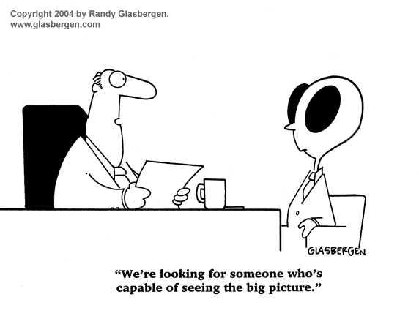
MEETING AN ALIEN

13.1 Make up a role play with your friend in which you interview an alien from outer space. Ask your friend questions starting with the words below.


13.2 Now fill in your questions and the alien’s answers.

You | The alien
What................................................................  ........................................................................ | ...........................................................................  ...........................................................................
Where..............................................................  ........................................................................ | ...........................................................................  ...........................................................................
Why.................................................................  ........................................................................ | ...........................................................................  ...........................................................................
When...............................................................  ........................................................................ | ...........................................................................  ...........................................................................
Who.................................................................  ........................................................................ | ...........................................................................  ...........................................................................
How..................................................................  ......................................................................... | ...........................................................................  ...........................................................................

DATE: ________________________________ TOPIC: TELLING TALES
___________________________________________________________________
Activity 14: LANGUAGE STRUCTURES AND CONVENTIONS

CONTENT
- Write sentences.
Refresher!
Verbs are doing words.
Adjectives are describing words. Adjectives describe nouns.

Let’s look at adverbs
Adverb:
A word that describes a verb, an adjective, or another adverb.
Example:
- She drives carefully.
describes a verb
How does she drive?

- She’s a very good driver.
describes an adjective
How good a driver is she?
- She drives really well.
describes another adverb
How well does she drive?

14.1 Complete each sentence using the adverbs from the list. Underline the verb the adverb describes. (12)
slowly always quickly lovingly here when

14.1.1 Alien turtles move ______________________ .
14.1.2 ______________ did the aliens arrive in their space ship?
14.1.3 They have not been ___________________ before.
14.1.4 I saw the space ship and ran home ___________________.
14.1.5 The alien held the cat _______________________.
14.1.6 You must ________________ report space ship sightings.

DATE: ____________________________ TOPIC(4): LOOKING AT LANGUAGE
___________________________________________________________________
Activity 15: LANGUAGE STRUCTURES AND CONVENTIONS

CONTENT
- Nouns
- Adjectives
- Verbs
- Adverbs

Sort the underlined words into the correct columns.
Last night neon aliens quickly started a blazing fire. They zoomed down right above my quiet home and rapidly fired their missiles into the dark forest. These little green guys glowed brightly in the dark and their dripping fangs snapped loudly with the force of a hungry shark.

Nouns | Adjectives | Verbs | Adverbs
8 | 7 | 4 | 4


Mark any 20 of 23: (20)




Here are quotes from 4 of the 12 ways our phones are changing us.

Addicted to Distraction
If you’re a typical American, you check your smartphone an average of every 4.3 minutes. That’s 81,500 times a year.
Facebook? 70% of people check it daily (over one billion others around the world do the same!). On Facebook, Messenger, and Instagram alone, we spend at least 50 minutes a day.
Why are we so addicted? Reinke suggests we use digital distractions to keep work away, keep people away, or keep thoughts of eternity away.

Ignore Flesh and Blood
While I often use my phone to connect with flesh and blood people, I don’t want it to replace in-person encounters. Given the choice, face-to-face beats digital.
“We become content to ‘LOL’ with our thumbs or to cry emoticon tears to express our sorrow because we cannot (and will not) take the time to genuinely invest ourselves in real tears of sorrow. We use our phones to multitask our emotions.”
And in the car? Let’s please stop checking our phones while driving. It’s killing us.
“Talking on the phone while driving a vehicle makes you four times more likely to get into an accident, but texting while driving makes your chance of a crash twenty-three times more likely.”

Lose Our Literacy
Reinke points out that a few people actually read more books as a result of online interactions. (He is also the author of Lit! A Christian Guide to Reading Books, one of my favorite books I read in 2012.)
But more commonly, smartphone users read fewer books now.
“It can be said that literacy has fallen to such a degree that, for many Christians today (perhaps most Christians today), the Bible stands as the oldest, longest, and most complicated book we will ever try to read on our own.”
Plus, reading digitally teaches us to scan at fast speeds. Can we train ourselves to read online text slower?

Fear of Missing Out
Do you know what nomophobia is? No-mobile-phone phobia. FOMO (fear of missing out) hits us on two sides: anxiety that we’re not staying updated on information if we’re not checking our phone, and insecurity of not getting the affirmation we want if we’re offline.
“This desire for personal affirmation is perhaps the smartphone’s strongest lure, and it is only amplified when we feel the sting of loneliness or suffering in our lives. At the first hint of discomfort, we instinctively grab our phones to medicate the pain with affirmation. This habit could not be more damaging.”

Suggestions
Along with the bad news, Reinke also gives lots of suggestions in the book for ways to live smarter with our smartphones. (He doesn’t say get rid of them altogether; he’s no technophobe.)
These include:
1. Turn off all nonessential push notifications.
2. Delete expired, nonessential, and time-wasting apps.
3. Use a real alarm clock, not your phone alarm, to keep the phone out of your hands in the morning.
4. Guard your morning disciplines and evening sleep patterns by using phone settings to mute notifications between one hour before bedtime to a time when you can reasonably expect to be finished with personal disciplines in the morning (9 p.m. to 7 a.m., for example).
5. Recognize that much of what you respond to quickly can wait. Respond at a later, more convenient time.

Ask Your Family
Are you brave enough to take this suggestion?
“Invite your spouse, your friends, and your family members to offer feedback on your phone habits (more than 70 percent of Christians in my survey said nobody else knew how much time they spent online).”
Our phone use affects others in more ways than we realize.
“If I’m a social-media junkie, my lack of self-control feeds the social-media addiction in you. And the more I text and tweet and Snapchat, the more I drag you and others into the digital vortex of reciprocating obligation. . . .
Even something as simple as pulling out your smartphone in a crowd is ‘the new yawn’—everyone else around you will feel the immediate pull and lure to check their own phones.”
I highly recommend this book. We all can benefit by periodically evaluating why we are using our phones.
“Apps can help me stay focused on my Bible reading plans and help me organize my prayer life, but no app can breathe life into my communion with God. . . .
What shall it profit a man if he gains all the latest digital devices and all of the techniques of touch-screen mastery but loses his own soul?”
* * *
How do you use your phone the most? Calls? Texts? Apps? Please share your thoughts here.
Read the preface and introduction here of 12 Ways Your Phone Is Changing You.
Related:
- Where Is Your Phone Right Now?
- Should You Get Off Facebook?
- Unfollow a Friend on Facebook to Keep a Friend
- Book: The Happiness Effect: How Social Media is Driving a Generation to Appear Perfect at Any Cost by Donna Freitas

One suggestion you gave in the comments that day (thanks, Lynn Morrissey) was to read the new book by Tony Reinke, 12 Ways Your Phone Is Changing You.

Signs and Symptoms of Cell Phone Addiction
Although cell phone addiction is not yet listed in the Diagnostic and Statistical Manual of Mental Disorders, 5th Edition (DSM-5), research has compared it to gambling addiction, which has clearer diagnostic criteria and is included in the DSM-5.
At least 4 of the following signs and symptoms are thought to comprise criteria for cell phone addiction, and the problematic cell phone overuse must cause significant harm in the individual’s life:^{2,3}
- A need to use the cell phone more and more often in order to achieve the same desired effect.
- Persistent failed attempts to use cell phone less often.
- Preoccupation with smartphone use.
- Turns to cell phone when experiencing unwanted feelings such as anxiety or depression.
- Excessive use characterized by loss of sense of time.
- Has put a relationship or job at risk due to excessive cell phone use.
- Tolerance.
  - Need for newest cell phone, more applications, or increased use.
- Withdrawal, when cell phone or network is unreachable.
  - Anger.
  - Tension.
  - Depression.
  - Irritability.
  - Restlessness.
If you or a loved one displays these signs and symptoms of cell phone addiction, help is readily available. Call the phone number above to speak with a treatment specialist about various recovery options.

Physical Effects of Addiction

Overuse of your cell phone or smartphone can result in a number of different physical problems that may cause permanent damage or be difficult to treat, including:
- Digital eye strain.⁴
  - The pain and discomfort associated with viewing a digital screen for over 2 hours.
  - Eyes begin to burn and itch.
  - Blurred vision.
  - Eye fatigue.
  - Digital Eye Strain can cause headaches.
- Neck problems.
  - Also known as “text neck,” which refers to neck pain resulting from looking down at cell phone or tablet for too long.⁵
- Increased illnesses due to germs.⁶
  - 1 in 6 cell phones has fecal matter on it.
  - E. coli bacteria, which can cause fever, vomiting, and diarrhea, is found on many phones.
  - Phones have been found to be contaminated with MRSA.
    - Causes painful abscesses.
    - Life-threatening infections in bones, joints, surgical wounds, bloodstream, heart valves, and lungs.
- Car accidents.
  - Many people believe that they can multitask and use their phones while driving, but this causes significant impairment and puts the driver and others on the road in danger.
  - Research has revealed that texting and driving can be just as dangerous as drinking and driving.⁷
- Male infertility.
  - Preliminary studies have revealed that cell phone radiation may decrease sperm count, sperm motility and viability.⁸

Psychological Effects of Cell Phone Addiction
- Sleep disturbances.⁹
  - Cell phone addiction has been linked to an increase in sleep disorders and fatigue in users.
  - Using your cell phone before bed increases the likelihood of insomnia.
    - Bright light may decrease sleep quality.
    - Smartphone use could increase amount of time it takes to fall asleep.
    - Light emitted from the cell phone may activate the brain.
- Depression.¹⁰
- Obsessive Compulsive Disorder.¹⁰
- Relationship problems.
  - Offline relationships may suffer as a result of neglect in favor of excessive cell phone and social media use.¹¹
- Anxiety.
  - Research has found that college students who use their cell phones the most are more likely to feel anxious during downtime.¹²

Am I Addicted to my Smartphone?
This self-assessment is not meant to officially diagnose you with cell phone addiction. If you are concerned about your problematic behaviors, speak to your doctor or mental health professional about possible treatment.¹³
- Do you find yourself spending more time on your smartphone than you realize?
- Do you find yourself mindlessly passing time on a regular basis by staring at your smartphone even though there might be better or more productive things to do?
- Do you seem to lose track of time when on your cell phone?
- Do you find yourself spending more time texting, tweeting, or emailing as opposed to talking to real-time people?
- Has the amount of time you spend on your cell phone been increasing?
- Do you secretly wish you could be a little less wired or connected to your cell phone?
- Do you sleep with your smartphone on or under your pillow or next to your bed regularly?
- Do you find yourself viewing and answering texts, tweets, and emails at all hours of the day and night, even when it means interrupting other things you are doing?
- Do you text, email, tweet, or surf the internet while driving or doing other similar activities that require your focused attention and concentration?
- Do you feel your use of your cell phone actually decreases your productivity at times?
- Do you feel reluctant to be without your smartphone, even for a short time?
- When you leave the house, you ALWAYS have your smartphone with you and you feel ill-at-ease or uncomfortable when you accidentally leave your smartphone in the car or at home, or you have no service, or it is broken?
- When you eat meals, is your cell phone always part of the table place setting?
- When your phone rings, beeps, buzzes, do you feel an intense urge to check for texts, tweets, or emails, updates, etc.?
- Do you find yourself mindlessly checking your phone many times a day even when you know there is likely nothing new or important to see?

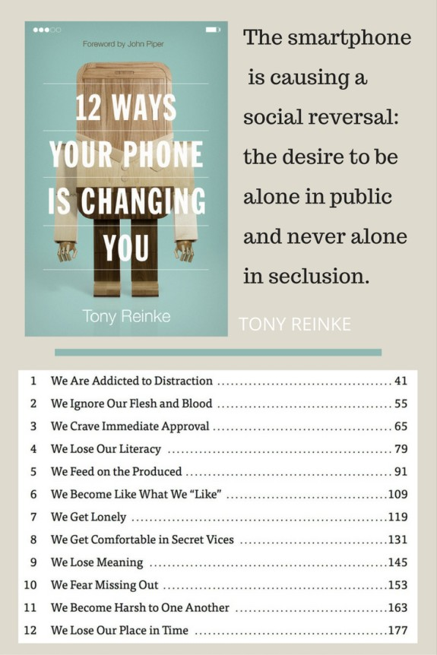

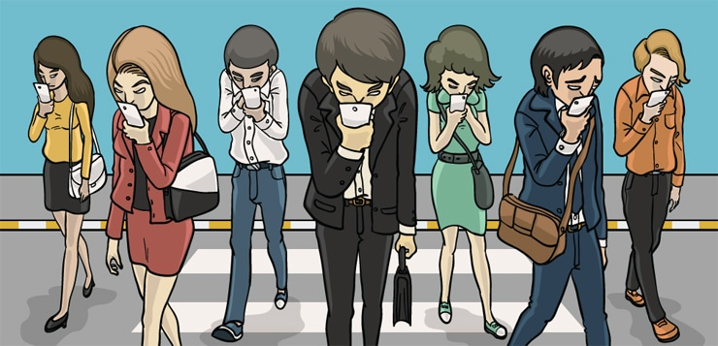
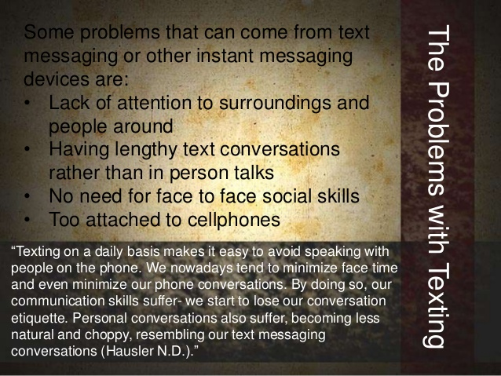
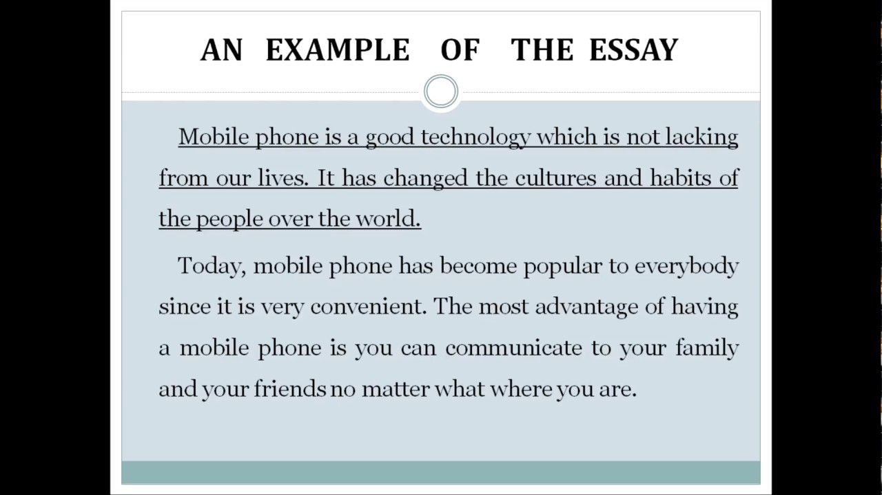
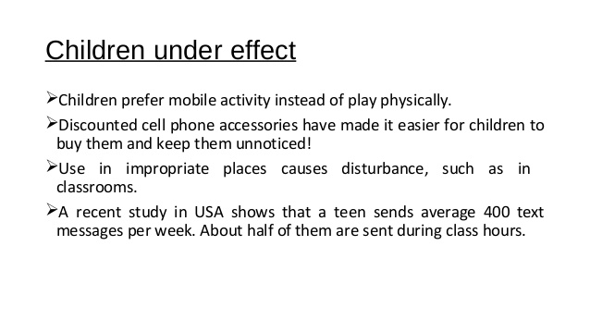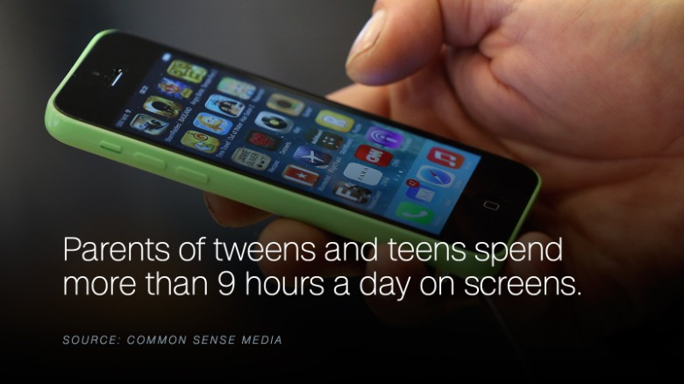
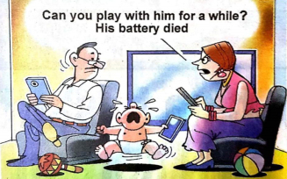
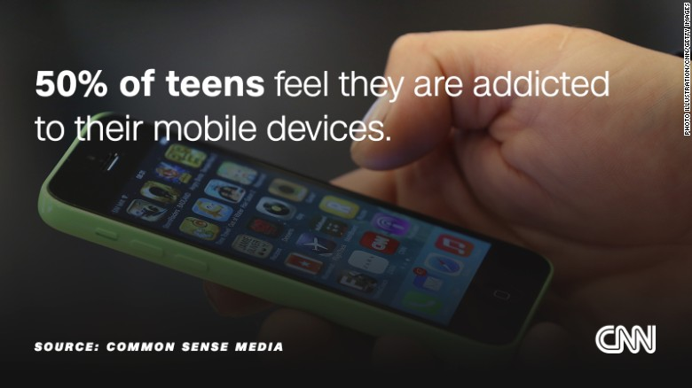

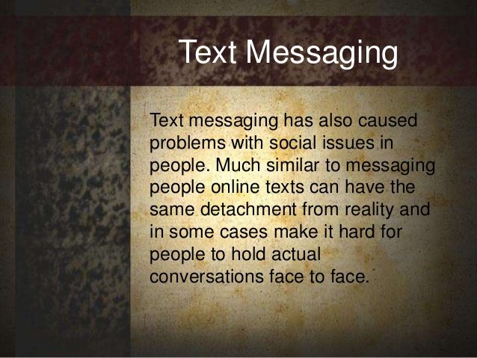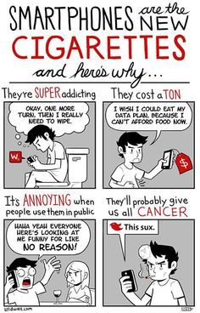
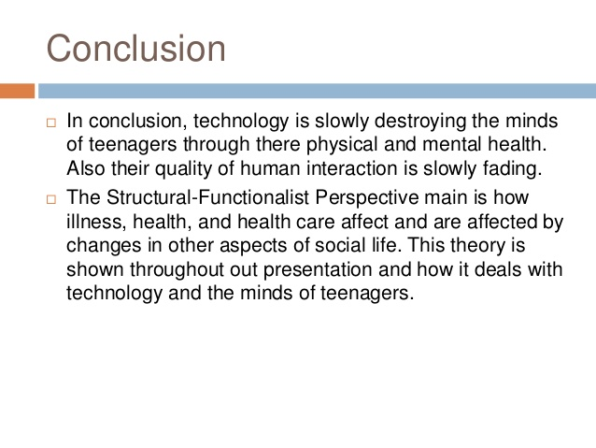


Rubric to assess a discussion
Listening and speaking  30 marks | Level 4 | Level 3 | Level 2 | Level 1
 | 8-10 | 6-7 | 4-5 | 1-3
Participation in debate | Skilfully sustains a conversation; listens to others with respect; takes turns; justifies own point of view; shows excellent understanding of the topic | Takes part in the discussion; listens to others with respect; takes a point of view and sometimes justifies it; takes turns; shows understanding of the topic | Takes part in the discussion adequately; able to listen and follow; few interruptions of others; defends viewpoint adequately; shows some understanding of the topic | Takes little or no part in the discussion; does not listen to others; or frequently interrupts; does not follow the thread of the debat; does not take a viewpoint
Ability to express self orally | Expresses her/himself very well. Able to say what he/she wants to say clearly and easily with few or no mistakes. | Expresses him/herself well. Able to say what he/she wants to say clearly and fairly easily, but with some mistakes. | Expresses him/herself with some difficulty. Struggles to say what he/she wants to say and makes many mistakes. | Struggles to express him/herself orally. Makes many mistakes. Difficult to understand. Says only one or two words.
Voice projection and modulation | Excellent | Very good | Poor | Hampers communication
TOTAL | 30


Tips for the Receptionist or Secretary


Presenting a professional image, both in person and on the telephone, is very important in the Office Skills profession. Taking care of your customers over the telephone and making them feel well informed and appreciated is essential. Whether you are the front office receptionist or an executive secretary, the following phone tips should always be followed.
1. Speak clearly. A picture paints a thousand words but the caller on the other end of the phone can only hear you. They cannot see your face or body language. Therefore, taking the time to speak clearly, slowly and in a cheerful, professional voice is very important.
2. Use your normal tone of voice when answering a call. If you have a tendency to speak loud or shout, avoid doing so on the telephone.
3. Do not eat or drink while you are on telephone duty. Only eat or drink during your coffee break or lunch break.
4. Do not use slang words or Poor Language. Respond clearly with “yes” or “no” when speaking. Never use swear words.
5. Address the Caller Properly by his or her title. (i.e. Good morning Mr. Brown, Good afternoon Ms. Sanders). Never address an unfamiliar caller by his or her first name.
6. Listen to the Caller and what they have to say. The ability to listen is a problem in general but it is very important to listen to what the caller has to say. It is always a good habit to repeat the information back to the client when you are taking a message. Verify that you have heard and transcribed the message accurately.
7. Be patient and helpful. If a caller is irate or upset, listen to what they have to say and then refer them to the appropriate resource. Never snap back or act rude to the caller.
8. Always ask if you can put the caller on hold. If you are responsible for answering multiple calls at once, always ask the caller politely if you may put them on hold. Remember that the caller could have already waited several minutes before getting connected to you and may not take lightly to being put on hold. Never leave the person on hold for more than a few seconds or they may become upset and hang up.
9. Always focus on the call. Try not to get distracted by people around you. If someone tries to interrupt you while you are on a call, politely remind them that you are on a customer call and that you will be with them as soon as you are finished.

Making Calls

1. Always identify yourself properly. When calling a client or customer, whether in person or when leaving a message, always identify yourself properly by providing your name, company name and contact telephone number. For example, "Good afternoon Mr. Brown, this is Ms. Brown from Officeskills.org. My telephone number is 408-555-1212." Always be aware of confidential information when leaving messages. Also, be aware of people around you while talking on the phone. Be discreet! Someone next to you might overhear confidential information that could negatively affect your business.
2. Avoid leaving long winded messages. Remember, someone has to listen to your message, write it down and then act upon it. Your message may be just one of many messages that need to be handled. It is often a good habit to write down or type out your message in advance. Keep it brief and to the point.

